Lab Experiments
SET -2
S. V. K. Sharon Surya
192324246

1.
# Customer Satisfaction Dataset
customer <- data.frame(
Customer_ID = c(1,2,3,4,5),
Age = c(25,30,35,28,40),
Satisfaction = c(4,5,3,4,5)
)

customer

# Histogram of Customer Ages

hist(customer$Age,
col = "lightblue",
main = "Distribution of Customer Ages",
xlab = "Age",
ylab = "Frequency",
breaks = 5)
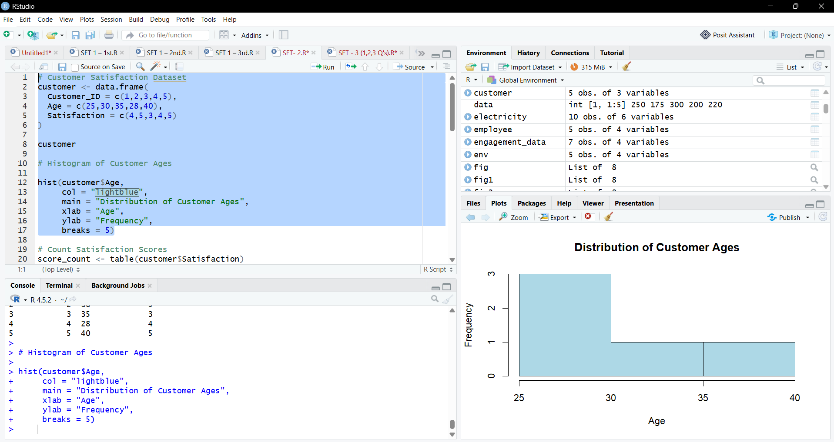
2.
# Pie Chart
pie(score_count,
labels = names(score_count),
col = rainbow(length(score_count)),
main = "Customer Satisfaction Scores")

# Create Age Groups
customer$Age_Group <- cut(customer$Age,
breaks = c(20,30,40,50),
labels = c("21-30","31-40","41-50"),
include.lowest = TRUE)

# Table
stack_data <- table(customer$Age_Group,
customer$Satisfaction)
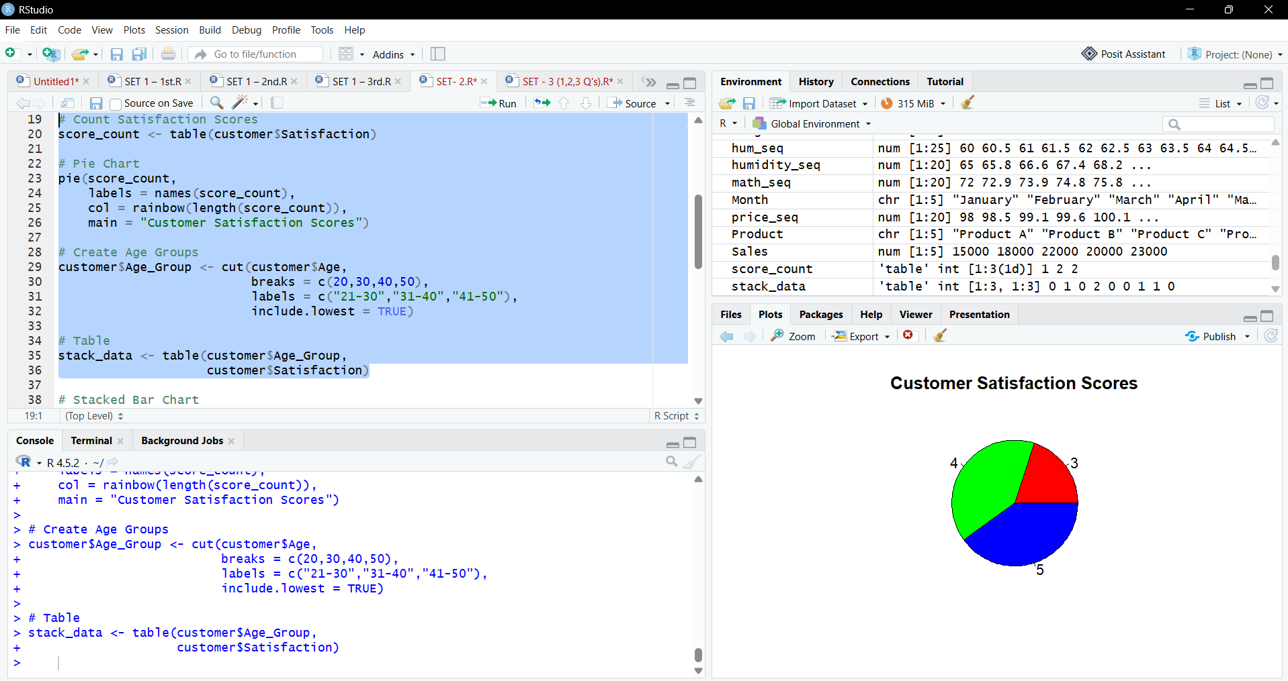

3.
# Stacked Bar Chart
barplot(stack_data,
col = rainbow(3),
legend = rownames(stack_data),
main = "Customer Satisfaction by Age Group",
xlab = "Satisfaction Score",
ylab = "Number of Customers")
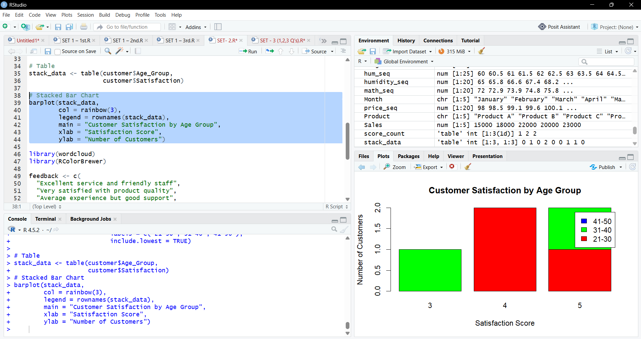

4.
library(wordcloud)
library(RColorBrewer)

feedback <- c(
"Excellent service and friendly staff",
"Very satisfied with product quality",
"Average experience but good support",
"Fast delivery and excellent packaging",
"Highly satisfied and will recommend"
)

text <- paste(feedback, collapse = " ")
words <- strsplit(tolower(text), "\\s+")[[1]]

wordcloud(
words = words,
max.words = 30,
random.order = FALSE,
colors = brewer.pal(8, "Dark2")
)
